- 整个文档页边距：
上2下2；左3右2cm
页脚边距：1.1

- 正文部分（参照正文格式）
中文除标题有特别规定外均用宋体，英文用Times New Roman体。正文段落用1.3倍行间距，段前段后均0磅。
定稿后请删除所有文本框！



本科生毕业设计（论文）外文资料译文

（ 2024届）
四号楷体，短题目居中，超过一行的长题目手动换行，均居左。请不要改变字体字号。题目确保与系统内的一致

论文题目 | 基于手机系统的宠物信息交流平台微信小程序的设计与实现
小四号楷体，居中

学生姓名 | 张子轩 | 学号 | 2022210402023
专业 | 计算机科学与技术 | 班级 | 计算机224
指导教师 | 陈立东 | 职称 | 讲师
班级名称：
班级名：
计算机201
计算机202
计算机203
计算机204
计算机205
计算机206
软工201
软工202
物联网201
计算机2208
计算机2209
计算机2210

专业名称写全称
计算机科学与技术（师范）
计算机科学与技术（金融信息服务）
计算机科学与技术
软件工程
物联网工程
地理信息科学
计算机科学与技术（专升本）
PS:若名称过长可适当缩小字号调整到同一行

信息科学与技术学院

外文资料译文规范说明
一、译文文本要求
1．外文译文不少于3000汉字；
2．外文译文本文格式参照论文正文规范（标题、字体、字号、图表、原文信息等）；
3．外文原文资料信息列文末，对应于论文正文的参考文献部分，标题用“外文原文资料信息”，内容包括：
1）外文原文作者；
2）书名或论文题目；
3）外文原文来源：
□出版社或刊物名称、出版时间或刊号、译文部分所在页码
□网页地址
二、外文原文资料（电子文本或数字化后的图片）：
1．外文原文不少于10000印刷字符（图表等除外）；
2．外文原文若是纸质的请数字化（图片）后粘贴于译文后的原文资料处，但装订时请用纸质原文复印件附于译文后。
整页替换：
导师意见从系统导出，然后替换本页。

指导教师意见：

指导教师签名： 年 月 日

一、外文资料译文：

基于 Vue.js 和 MySQL 的电子商务平台的设计与实现
关键词：Vue.js，MySQL，电子商务，电子元器件选型

研究背景
在网络信息时代，信息技术已广泛应用于各行各业，电子商务网站成为重要的销售渠道。电子商务网站的建设不仅实现了服务的信息化，还拓展了网络交易与支付功能，在提升服务质量的同时，也极大地方便了人们的日常工作与生活。
提到网络购物，人们往往首先想到淘宝、天猫、京东等主流电子商务平台。众多品牌、企业店铺以及官方旗舰店希望在大型平台上分得一部分流量。除了依赖天猫、京东等大型电商平台，越来越多的商家开始为自身产品搭建专属的在线商店，从而为已有客户群体提供更加便捷的购物平台。
技术改变了生活，而电子商务网站成为这一变化最直接的载体。如何高效、快速地开发网站成为企业成功的关键。由于不同电子商务业务存在差异，各类电商网站在功能实现上也不尽相同。本文构建的是一个面向电子元器件选型的电子商务平台。图1展示了系统的登录界面。
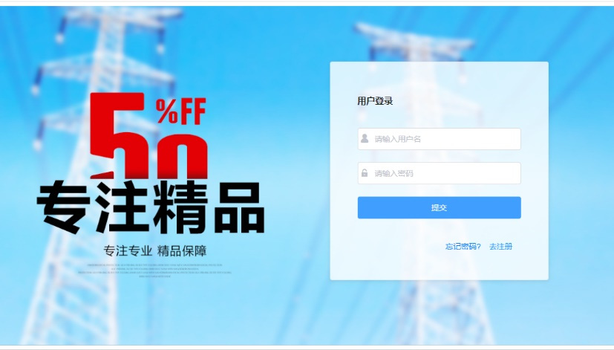
图 1System login interface

主要技术介绍

Vue.js
传统开发方式通常将前端代码与后端代码混合在一起，例如 ASP、JSP 等技术。这种开发模式需要在前后端代码之间频繁穿插，导致代码可读性差、开发效率低。基于此，前后端分离的开发架构应运而生。
本项目采用 Vue.js 作为前端开发框架，该框架属于当前主流且先进的前端技术。通过 Vue.js 的应用，提高了网站开发效率，使代码逻辑更加清晰，能够更好地应对需求变化，同时系统更易于维护与集成，从而降低了整体开发成本。

Java SSM 框架
SSM 是 Spring、SpringMVC 与 MyBatis 三个开源框架的整合框架，常用于中小型 Web 项目。
Spring 是一种轻量级的控制反转（IoC）和面向切面编程（AOP）容器框架；SpringMVC 将控制器、模型对象、调度器与处理器进行分离，增强了系统的可扩展性；MyBatis 是优秀的持久层框架，支持 SQL 查询、存储过程以及高级映射。

MySQL
MySQL 是目前最流行的开源关系型数据库管理系统之一，具有速度快、灵活性高的特点。系统采用 MySQL 实现数据的存储、修改、删除与查询功能，使数据管理更加系统化和科学化。
系统设计分为前台与后台两部分：前台面向用户，后台面向系统管理员。前台提供商品浏览、信息查看、用户注册、登录、在线下单、购物车等功能；后台则包括数据维护、订单处理、商品信息管理等功能。前端、后端与数据库共同构成一个完整的电子商务系统，其结构如图2所示。
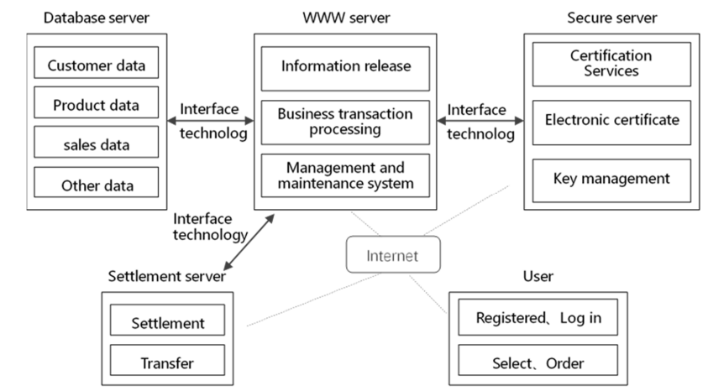
图 2 Website structure

系统功能模块设计与实现
根据需求分析，电子元器件选型电商网站主要包括用户管理、元器件维护、订单管理与在线支付等功能模块，如图3所示。
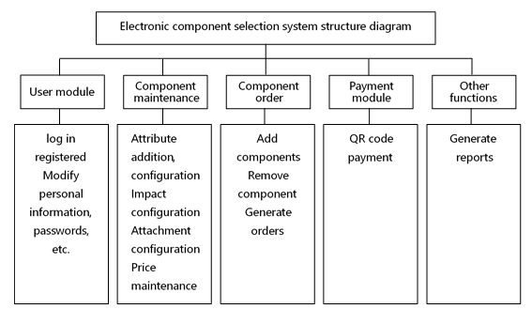
图 3 System function module

用户模块
用户管理模块主要包括会员注册、登录、个人信息管理以及历史信息管理等功能。在管理用户个人资料、历史记录及在线信息的过程中，系统必须确保用户隐私和数据安全。

元器件维护
企业产品种类繁多，系统通过数据库为用户提供高效、准确的信息检索与查询服务，使用户能够快速定位所需产品信息。这体现了网站在信息组织与信息传递方面的能力。

元器件订单
用户点击商品后，系统将展示商品的文字说明、图片和属性信息。用户可以自由选择不同属性，系统参数将随之动态更新。购物车管理支持商品添加、修改与删除等操作。用户提交订单后，系统会返回确认信息以确保订单数据的准确性。
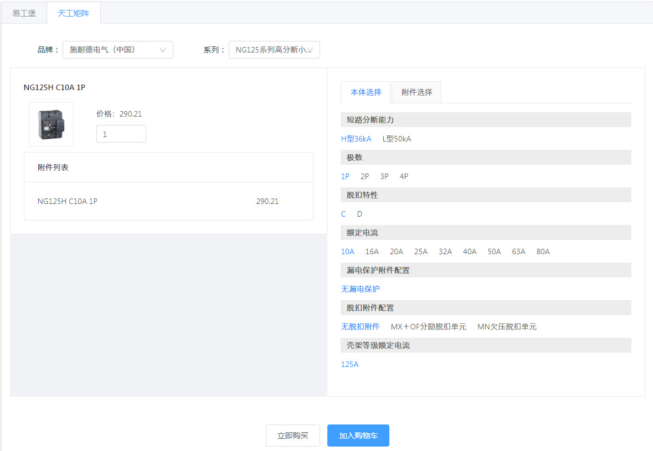
图 4 Product attributes and ordering interface

支付模块
在线支付是电子商务的重要组成部分。通过互联网电子支付方式，使购物过程更加便捷，实现电子商务流程的完整性。在线支付依赖银行或信用卡机构提供的电子金融服务支持。

其他功能
客户信息管理是体现网站是否以客户为中心的重要增值功能。成功的电子商务网站应具备良好的交互性，通过收集和分析用户数据，为企业管理者提供决策支持。

创新点

纵向数据存储
电子元器件具有数据量大、属性多、属性间关系复杂等特点，传统的横向数据库设计难以满足需求。本文采用纵向数据存储方式，以更好地适应元器件属性变化。
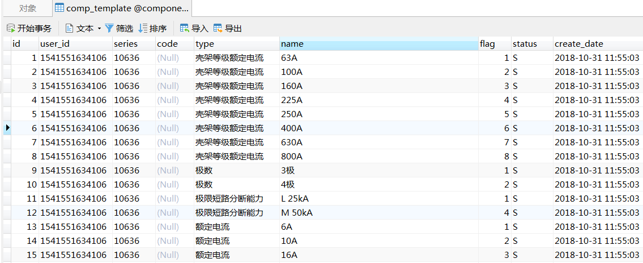
图 5 Table structure window

二叉树遍历
由于元器件参数之间存在复杂的层级影响关系，本文通过二叉树遍历算法实现参数之间的联动变化。
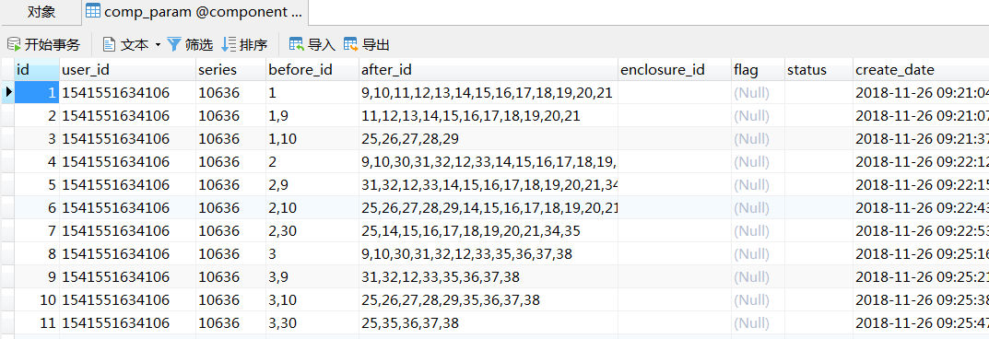
图 6 Parameter settings

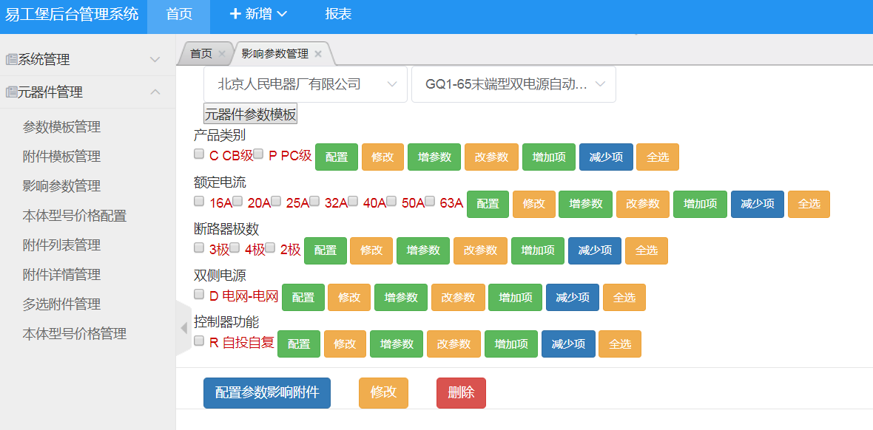
图 7 Parameter management window

结论
随着网络信息技术的发展，企业日益重视互联网在品牌建设与市场拓展中的作用。电子商务网站通过拓展线下交易、建立在线展示与交易平台，有效降低成本并提升销售额。本文所设计的电子元器件电商平台运行效率高、管理便捷，提升了运营人员、商家和用户的整体体验，但在数据库表结构设计方面仍有进一步优化空间。

参考文献
- Zhang Yaochun, Huang Yi, Wang Jing etc.Vue.js authoritative guide[M]. Beijing: Electronic Industry Press,2016.
- Zou Hongting. Research and Application of Web System Based on SSM Framework [J]. Journal of Hunan Institute of Science and Technology (Natural science edition),2017,30(01):39-43.
- Selakovic M. Pradel M. Performance issues and optimizations in JavaScript: an empirical study[C]//Ieee/acm, Internatio Conference on Software Engineering. IEEE, 2017: 61-72.
- Huang Wenjuan. Design of Library Information Management System Based on Java and MySQL [J]. Electronic design engineering.2019(02).

外文原文资料信息
- 外文原文作者： Yun Quan
- 外文原文所在书名或论文题目：Design and Implementation of E-commerce Platform based on Vue.js and MySQL
- 外文原文来源：Proceedings of the 3rd International Conference on Computer Engineering, Information Science & Application Technology(ICCIA 2019)
出版社或刊物名称、出版时间或刊号、译文部分所在页码：2019-05-30
网页地址：https://link.cnki.net/doi/10.26914/c.cnkihy.2019.055856

二、外文原文资料：
Design and Implementation of E-commerce Platform based on Vue.js and MySQL

Keywords: Vue.js MySQL, e-commerce, electrical component selection.

Background
In the era of network information, information technology is widely used in all walks of life, and e-commerce websites have become an important sales channel. The construction of e-commerce website not only realizes service informationization, but also opens up network transaction and payment functions, which facilitates people's daily work and life while improving service quality.
Many people who mention online shopping immediately think of mainstream e-commerce platforms such as Taobao, Tmall, and Jingdong. Many brands, various corporate stores, and official flagship stores want to share a “flow” on the big platform. In addition to relying on large e-commerce platforms such as Tmall and Jingdong, more and more businesses are starting to build suitable online stores for their products, thus creating a more convenient shopping platform for their accumulated customer base.
Technology has changed lives, and e-commerce sites have become the most direct carrier of this change. How to develop websites efficiently and quickly becomes the key to success for the company. Since the e-commerce business carried out on the Internet is not the same, each e-commerce website has different implementation functions. This project is built on the e-commerce platform for the selection of electrical components. The following picture shows the website login interface.

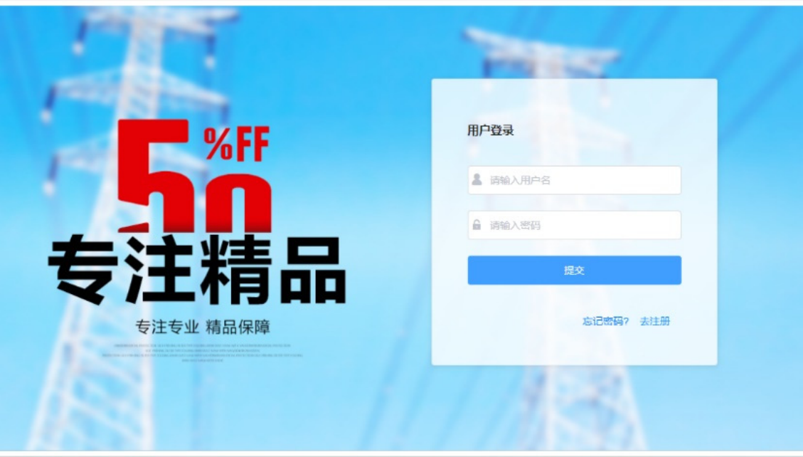
Fig. 1 System login interface

Main Technical Introduction

Vue.js.
The traditional development method mixes the front-end code and the back-end code, such as ASP, JSP technology, etc. This development mode needs to be interspersed in the front end and the back end, resulting in poor readability of the code and low development efficiency. In view of the above reasons, the development structure of the separation of the front and rear ends was born.
This project adopts the front-end part of Vue.js technology development platform based on mainstream and latest front-end development framework, which improves the development efficiency of the website, clearer code logic, easier to cope with the changing needs, and the system is easier to maintain and integrate so as to reduce development costs.

Java SSM Framework.
SSM, the integration framework of the three open source frameworks ofthe Spring+ SpringMVC +MyBatis.
SSM is often used as a framework for simpler Web projects for data sources. Spring is a lightweight control inversion (IoC) and aspect-oriented (AOP) container framework. SpringMVC separates the roles of controllers, model objects, dispatchers, and handler objects, making this easier to customize. MyBatis is an excellent persistence layer framework that supports common SQL queries, stored procedures and advanced mapping.

MySQL
MySQL is one of the most popular relational open source database management systems. It saves data in different tables and is fast and flexible. The system uses MySQL to realize the functions of storing, modifying, deleting and querying data, which enables more systematic and scientific management of data.
The front desk and the back office are two aspects of system design: the buyer corresponds to the front desk design, and the background corresponds to the system user. The front desk of the system can realize online shopping for users, and the front desk provides users with functions such as dynamic browsing, information viewing, user registration, login, online ordering, shopping cart and the like. The administrator privileges include data maintenance, order processing, product information management, and the more. Through the development of the background, the electrical components products are effectively displayed on the website. The front-end, back-end and database form a complete e-commerce website. The structure of the website is shown in Figure 2.
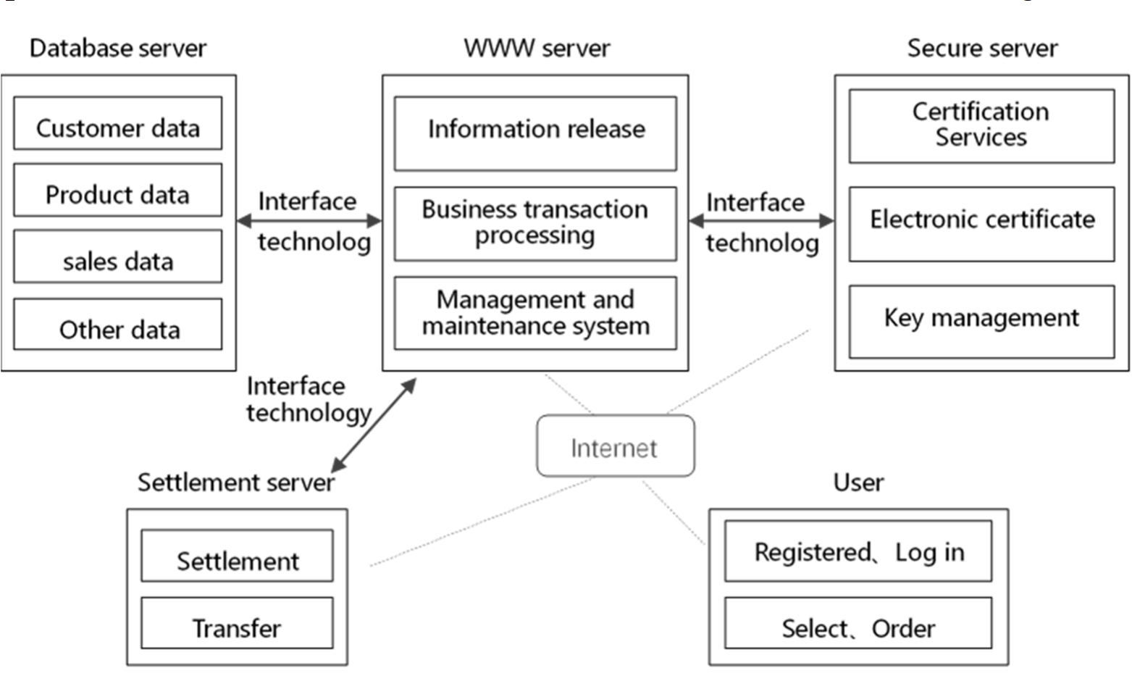

System Function Module Design and Implementation
According to the demand, the e-commerce website for selecting electrical components can be divided into several main functional modules such as user management, component background maintenance, component ordering, and online payment, as shown in Figure 3.

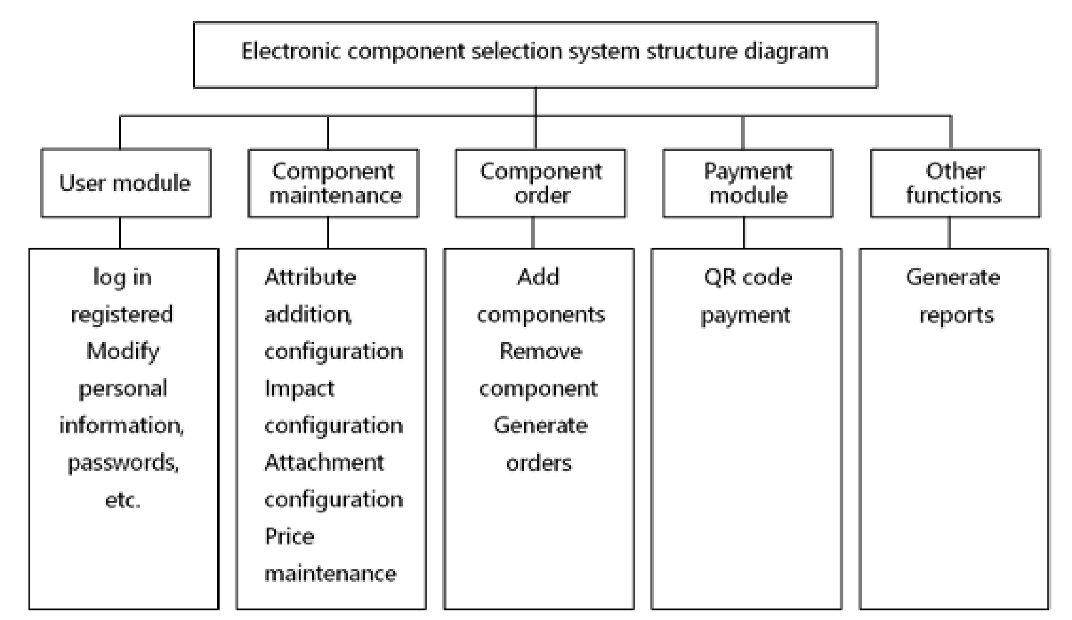
Fig. 3 System function module

User Module
The user management module mainly includes functions such as member registration, login, member personal data management, and member history information management. In the process of managing personal related materials, historical information, and online messages, the system needs to ensure the security of the member's personal information.

Component Maintenance
There are many kinds of products in the enterprise. The website uses the database to provide accurate and fast information searching and querying services for the viewers, so that the customers can easily and quickly find the required information in the e-commerce database. This is a function that reflects the ability of the website to organize the information and expand the way information is exchanged and delivered.

Component Order
When a user finds an item of interest, clicking on the item will display descriptive information such as the text, image, and attributes of the item. Users can also click on an attribute at will, and the parameters below the item will be updated accordingly, which is also a highlight of the project. There are many secondary functions in the management of the shopping cart, such as modifying, deleting, adding and other related functions in the shopping cart order. When the user wants to purchase, the product can be put into the shopping cart. When the customer fills out the order form, the system will reply the confirmation information sheet to ensure the receipt of the order information. Figure 4 below shows the product attributes and ord

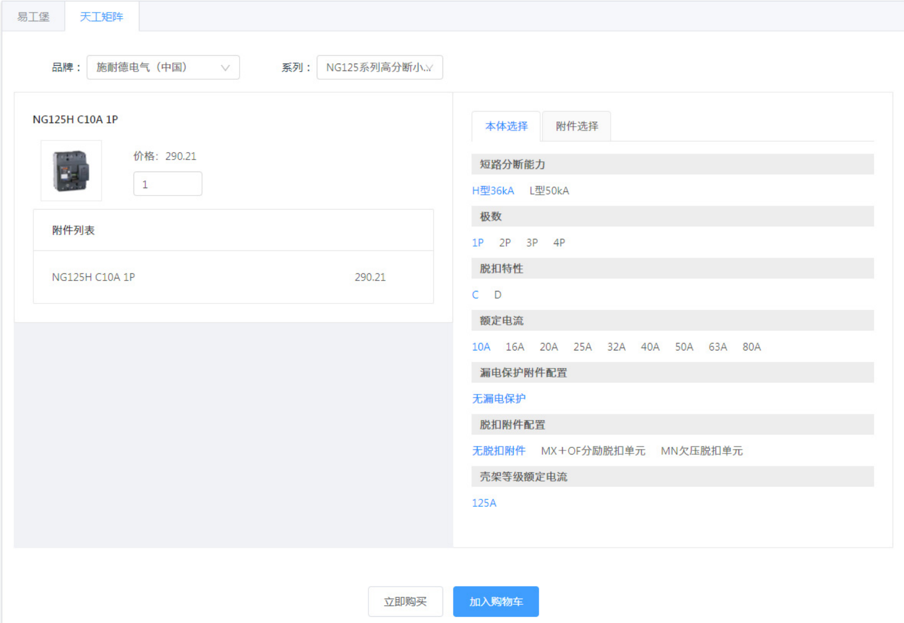
Fig. 4 Product attributes and ordering interface

Payment Module
In addition to the transactions, online payment is also an important part. The direct use of the electronic payment methods on the Internet makes online shopping more convenient, and makes e- commerce a complete process. Online payment must be supported by e-finance, that is, financial institutions such as banks or credit card companies must provide online operations for the financial services.

Other Functions
Customer information management is an important value-added function that reflects whether the main body of the website can be customer-centric and can fully utilize the customer information to tap the market potential. Successful websites must be interactive and interactive. Companies can use the website to collect information and then give managers decision support based on the results of these data analysis.

Innovation

Longitudinal Data Storage
The maintenance of product information is one of the important functions of the background. The electrical components have large amount of data, many attributes, and many interactions between attributes. The traditional horizontal database design is difficult to meet the parameters in the database application system. Therefore, we use vertical storage in the database in order to better adapt to the changes of the attributes of the components.
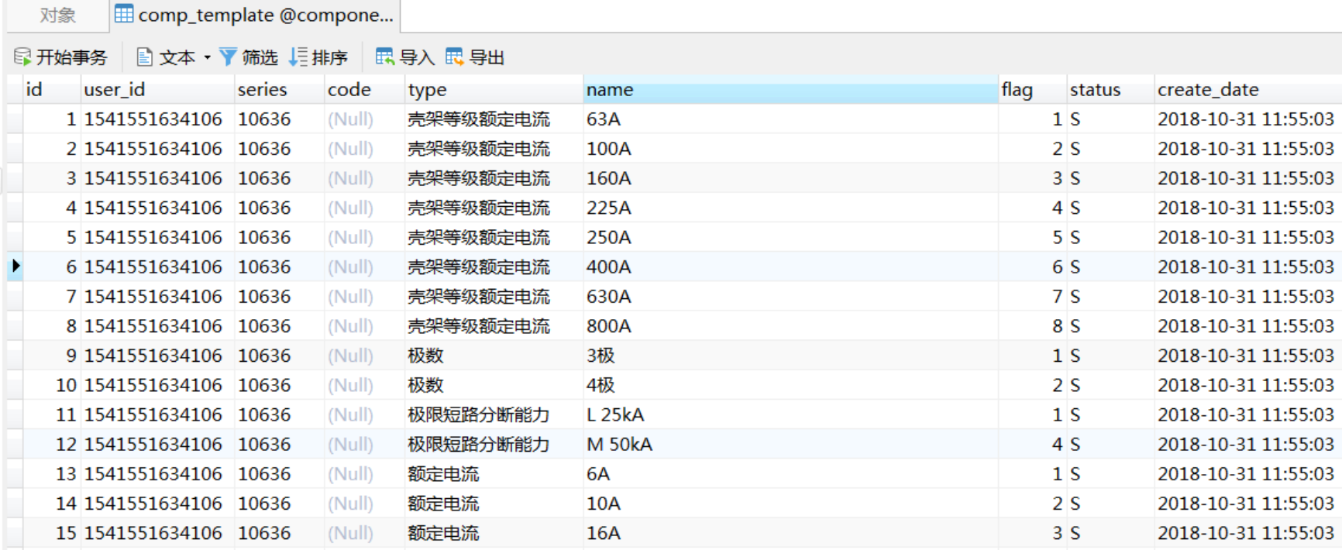
Fig. 5 Table structure window

Binary Tree Traversal
The influence between component parameters is very complicated. One parameter of the upper layer affects the parameters of the lower layer, and sometimes multiple parameters affect the parameters of the lower layer. In order to achieve such changes, we use the traversal of the binary tree to complete the effects between the parameters.

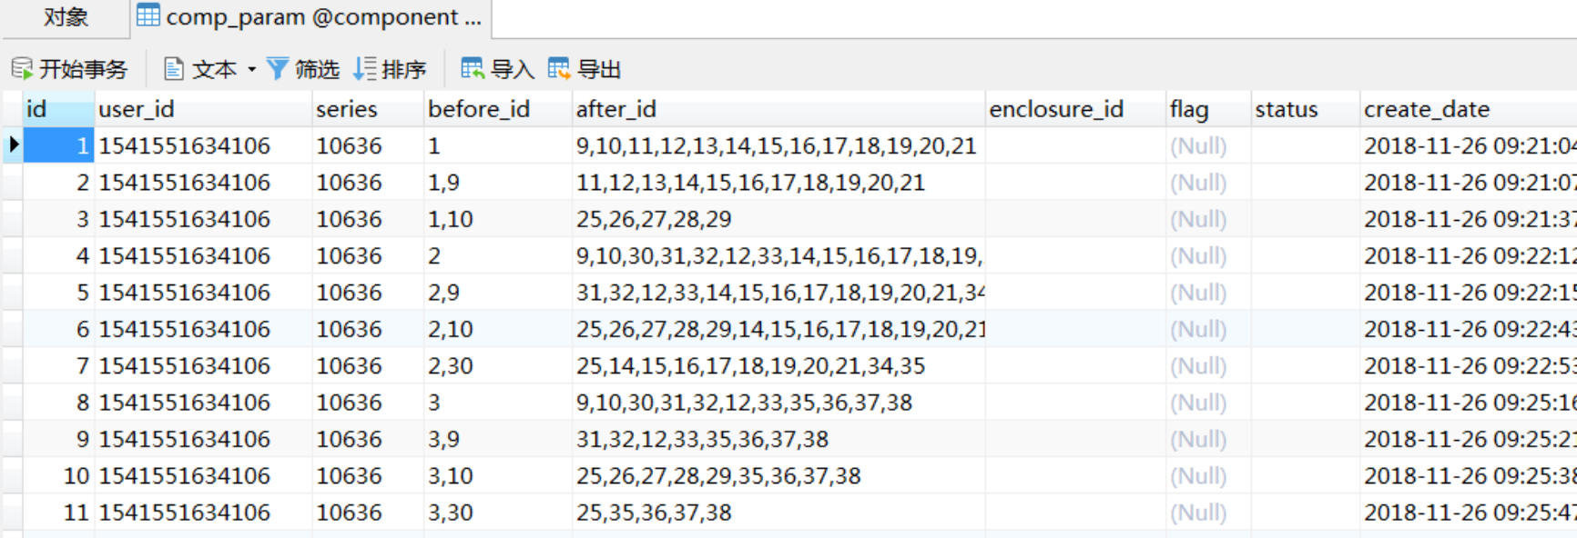
Fig. 6 Parameter settings

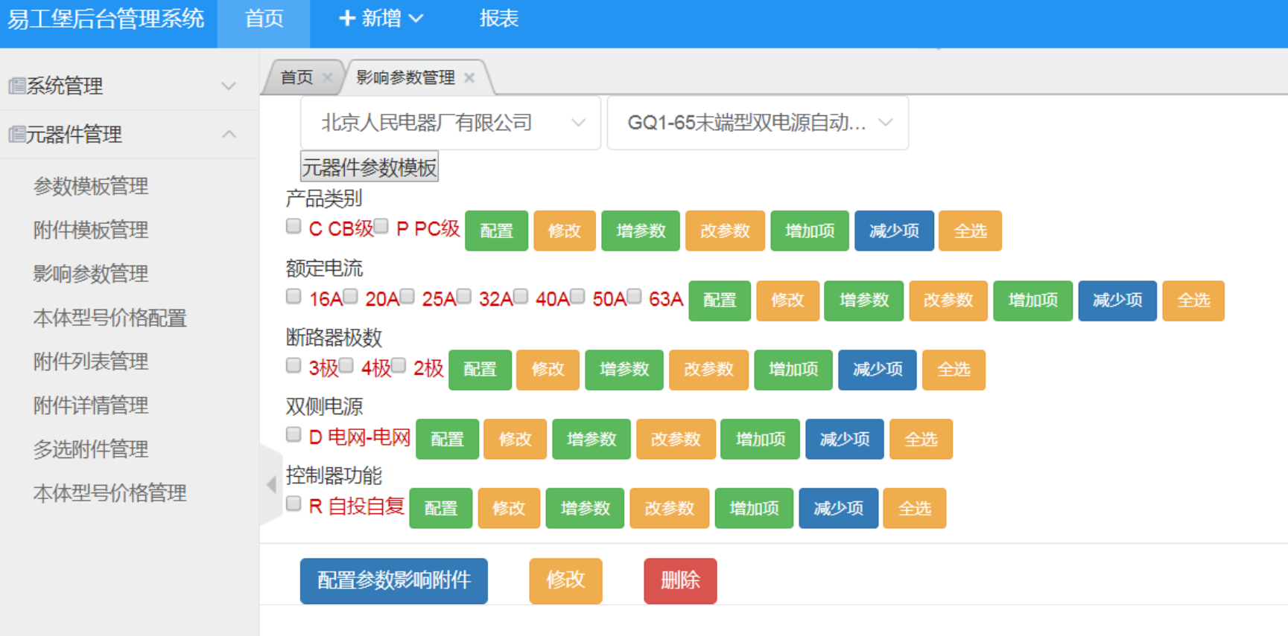
Fig. 7 Parameter management window

Conclusion
With the gradual development and popularization of network information technology, enterprises have realized the importance of using the Internet for brand building and market expansion. Internet consumption has become the main battlefield of network marketing, and the high-quality network marketing will bring more benefits to the company. The functions of e-commerce websites have the same goal. They make full use of the advantages of wide-ranging information dissemination and fast dissemination of Internet information, expand offline transactions, and establish online display and trading platforms. The selection of electronic components for e-commerce has reduced costs and increased sales. The website is running fast and it is easy to manage, and the system has improved the experience of operators, merchants and users. The method used in establishing the table structure is not simple enough, and the further research and optimization are needed.

References
- Zhang Yaochun, Huang Yi, Wang Jing etc.Vue.js authoritative guide[M]. Beijing: Electronic Industry Press,2016.
- Zou Hongting. Research and Application of Web System Based on SSM Framework [J]. Journal of Hunan Institute of Science and Technology (Natural science edition),2017,30(01):39-43.
- Selakovic M. Pradel M. Performance issues and optimizations in JavaScript: an empirical study[C]//Ieee/acm, Internatio Conference on Software Engineering. IEEE, 2017: 61-72.
- Huang Wenjuan. Design of Library Information Management System Based on Java and MySQL [J]. Electronic design engineering.2019(02).

